Image | 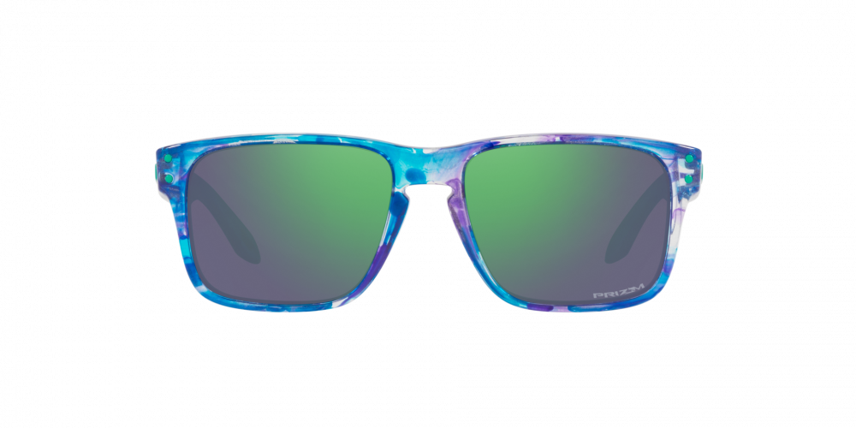
Brand | OAKLEY
Model Name | HOLBROOK™ XS SPIN-SHIFT
Price | RS 3499
PRODUCT DETAILS

